**Lampiran 7. Hasil Uji Normalitas**

1. ***Organizational Citizenship Behavior***

|  |  |  |  |  |  |  |
| --- | --- | --- | --- | --- | --- | --- |
| **Case Processing Summary** | | | | | | |
|  | Cases | | | | | |
| Valid | | Missing | | Total | |
| N | Percent | N | Percent | N | Percent |
| OCB_ | 78 | 100.0% | 0 | 0.0% | 78 | 100.0% |

|  |  |  |  |  |
| --- | --- | --- | --- | --- |
| **Descriptives** | | | | |
|  | | | Statistic | Std. Error |
| OCB_ | Mean | | 4.67 | .007 |
| 95% Confidence Interval for Mean | Lower Bound | 4.65 |  |
| Upper Bound | 4.68 |  |
| 5% Trimmed Mean | | 4.67 |  |
| Median | | 4.65 |  |
| Variance | | .004 |  |
| Std. Deviation | | .065 |  |
| Minimum | | 5 |  |
| Maximum | | 5 |  |
| Range | | 0 |  |
| Interquartile Range | | 0 |  |
| Skewness | | .107 | .272 |
| Kurtosis | | -.482 | .538 |

|  |  |  |  |  |  |  |
| --- | --- | --- | --- | --- | --- | --- |
| **Tests of Normality** | | | | | | |
|  | Kolmogorov-Smirnova | | | Shapiro-Wilk | | |
| Statistic | df | Sig. | Statistic | df | Sig. |
| OCB_ | .100 | 78 | .052 | .981 | 78 | .278 |
| a. Lilliefors Significance Correction | | | | | | |

**OCB**

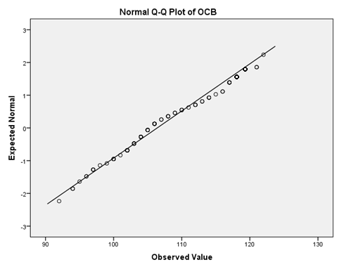

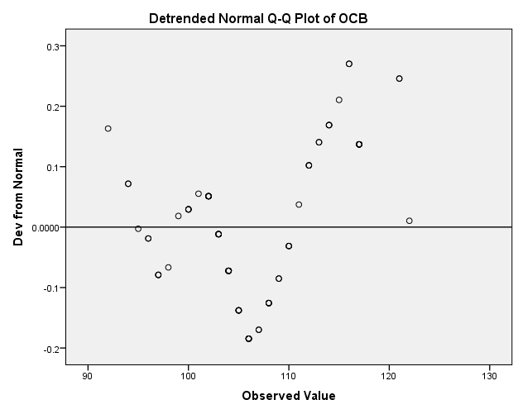

1. **Kepuasan Kerja**

|  |  |  |  |  |  |  |
| --- | --- | --- | --- | --- | --- | --- |
| **Case Processing Summary** | | | | | | |
|  | Cases | | | | | |
| Valid | | Missing | | Total | |
| N | Percent | N | Percent | N | Percent |
| KepuasanKerja_ | 78 | 100.0% | 0 | 0.0% | 78 | 100.0% |

|  |  |  |  |  |
| --- | --- | --- | --- | --- |
| **Descriptives** | | | | |
|  | | | Statistic | Std. Error |
| KepuasanKerja_ | Mean | | 4.61 | .007 |
| 95% Confidence Interval for Mean | Lower Bound | 4.60 |  |
| Upper Bound | 4.62 |  |
| 5% Trimmed Mean | | 4.61 |  |
| Median | | 4.60 |  |
| Variance | | .004 |  |
| Std. Deviation | | .066 |  |
| Minimum | | 4 |  |
| Maximum | | 5 |  |
| Range | | 0 |  |
| Interquartile Range | | 0 |  |
| Skewness | | .461 | .272 |
| Kurtosis | | -.005 | .538 |

|  |  |  |  |  |  |  |
| --- | --- | --- | --- | --- | --- | --- |
| **Tests of Normality** | | | | | | |
|  | Kolmogorov-Smirnova | | | Shapiro-Wilk | | |
| Statistic | df | Sig. | Statistic | df | Sig. |
| KepuasanKerja_ | .128 | 78 | .053 | .971 | 78 | .072 |
| a. Lilliefors Significance Correction | | | | | | |

**Kepuasan_Kerja**

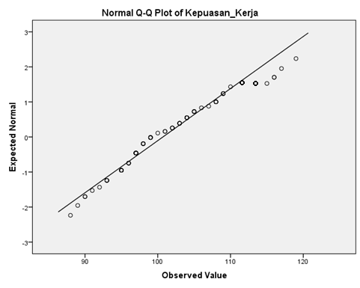

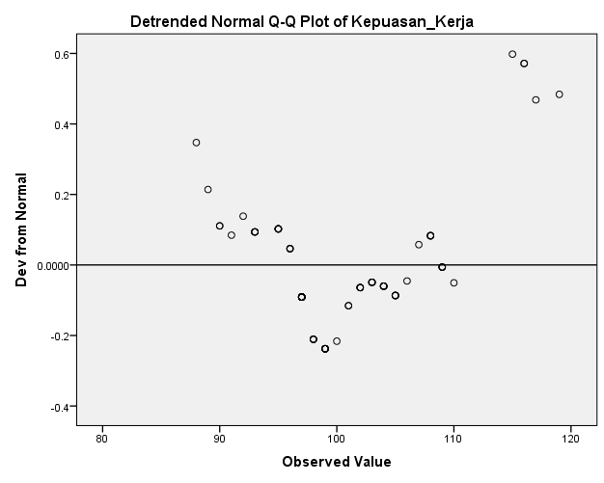

1. **Keadilan Organisasi**

|  |  |  |  |  |  |  |
| --- | --- | --- | --- | --- | --- | --- |
| **Case Processing Summary** | | | | | | |
|  | Cases | | | | | |
| Valid | | Missing | | Total | |
| N | Percent | N | Percent | N | Percent |
| KeadilanOrganisasi_ | 78 | 100.0% | 0 | 0.0% | 78 | 100.0% |

|  |  |  |  |  |
| --- | --- | --- | --- | --- |
| **Descriptives** | | | | |
|  | | | Statistic | Std. Error |
| KeadilanOrganisasi_ | Mean | | 4.64 | .007 |
| 95% Confidence Interval for Mean | Lower Bound | 4.62 |  |
| Upper Bound | 4.65 |  |
| 5% Trimmed Mean | | 4.63 |  |
| Median | | 4.62 |  |
| Variance | | .003 |  |
| Std. Deviation | | .058 |  |
| Minimum | | 5 |  |
| Maximum | | 5 |  |
| Range | | 0 |  |
| Interquartile Range | | 0 |  |
| Skewness | | .606 | .272 |
| Kurtosis | | .383 | .538 |

|  |  |  |  |  |  |  |
| --- | --- | --- | --- | --- | --- | --- |
| **Tests of Normality** | | | | | | |
|  | Kolmogorov-Smirnova | | | Shapiro-Wilk | | |
| Statistic | df | Sig. | Statistic | df | Sig. |
| KeadilanOrganisasi_ | .125 | 78 | .054 | .971 | 78 | .070 |
| a. Lilliefors Significance Correction | | | | | | |

**Keadilan_Organisasi**

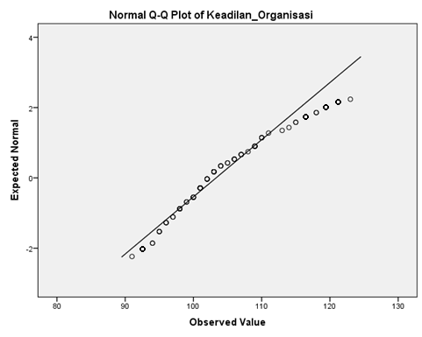

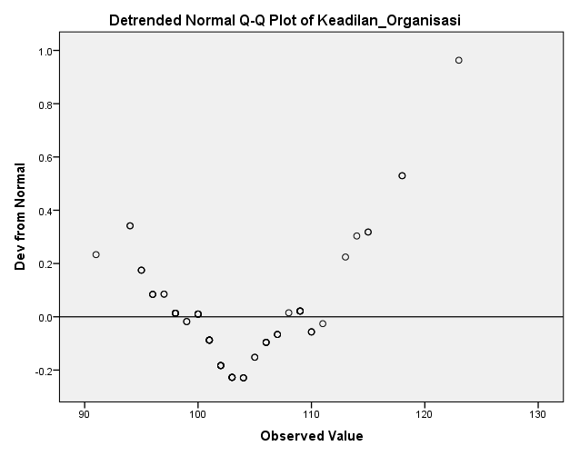

1. **Komitmen Organisasi**

|  |  |  |  |  |  |  |
| --- | --- | --- | --- | --- | --- | --- |
| **Case Processing Summary** | | | | | | |
|  | Cases | | | | | |
| Valid | | Missing | | Total | |
| N | Percent | N | Percent | N | Percent |
| KomitmenOrganisasi_ | 78 | 100.0% | 0 | 0.0% | 78 | 100.0% |

|  |  |  |  |  |
| --- | --- | --- | --- | --- |
| **Descriptives** | | | | |
|  | | | Statistic | Std. Error |
| KomitmenOrganisasi_ | Mean | | 4.62 | .007 |
| 95% Confidence Interval for Mean | Lower Bound | 4.61 |  |
| Upper Bound | 4.64 |  |
| 5% Trimmed Mean | | 4.62 |  |
| Median | | 4.61 |  |
| Variance | | .004 |  |
| Std. Deviation | | .064 |  |
| Minimum | | 5 |  |
| Maximum | | 5 |  |
| Range | | 0 |  |
| Interquartile Range | | 0 |  |
| Skewness | | .648 | .272 |
| Kurtosis | | -.179 | .538 |

|  |  |  |  |  |  |  |
| --- | --- | --- | --- | --- | --- | --- |
| **Tests of Normality** | | | | | | |
|  | Kolmogorov-Smirnova | | | Shapiro-Wilk | | |
| Statistic | df | Sig. | Statistic | df | Sig. |
| KomitmenOrganisasi_ | .110 | 78 | .052 | .951 | 78 | .005 |
| a. Lilliefors Significance Correction | | | | | | |

**Komitmen_Organisasi**

